|  |  |
| --- | --- |
| Pre-lab Worksheet  Active Science Resources—Pre-class and In-class  Experiment 7.2 *(Book 2A, Ch. 7, pp. 19–20)* | Name: _______________ Class: ____________( ) Date: ________________ |

7 Living Things and Air

Burning food

**1.** Before doing Experiment 7.2, let’s recall the correct way of lighting a Bunsen burner learnt in Book 1A Ch. 1, as follows:

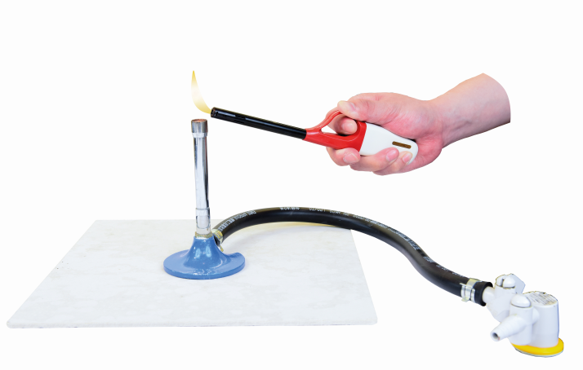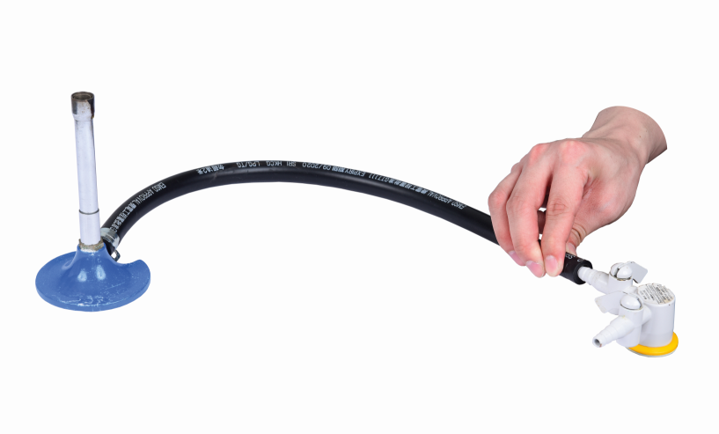

**1.** Check if the rubber tubing is tightly connected to the gas tap.

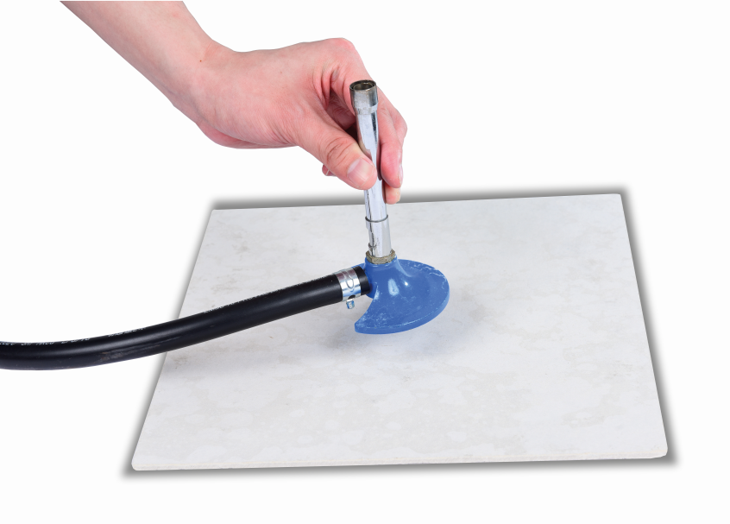

**2.** Put a heatproof mat under the Bunsen burner.

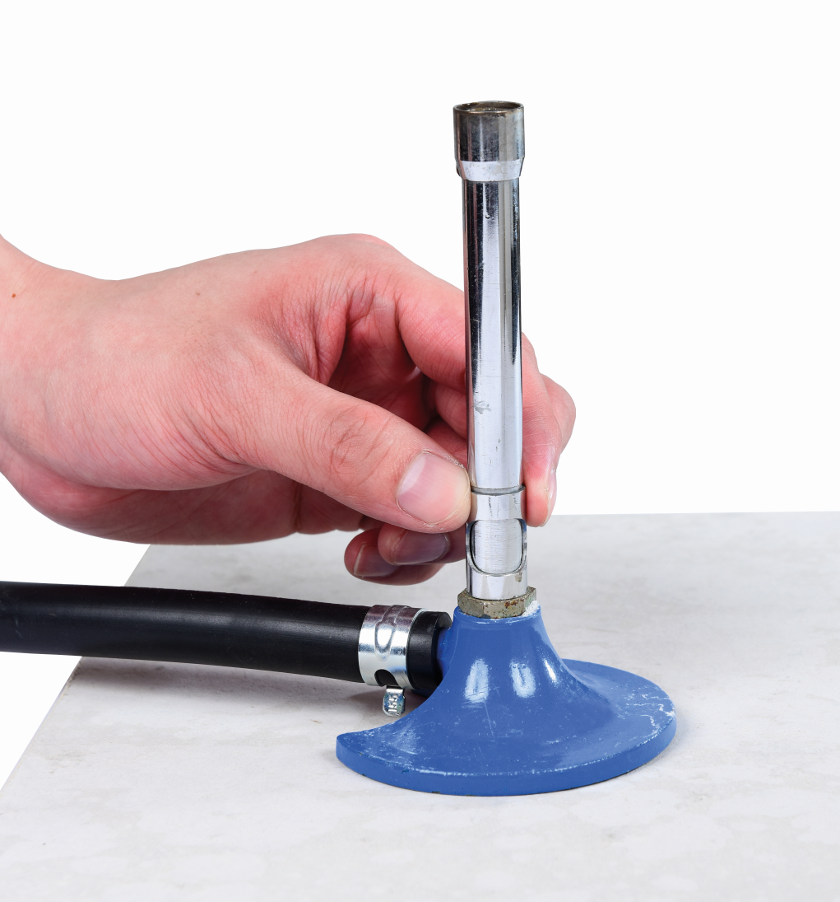

**3.** Turn the collar to close the air hole.

**4.** Put the tip of the gas lighter over the chimney. Ignite the gas lighter.

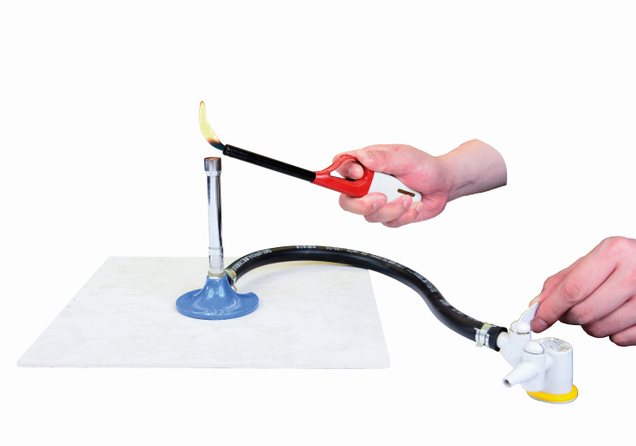

**5.** Turn on the gas tap.

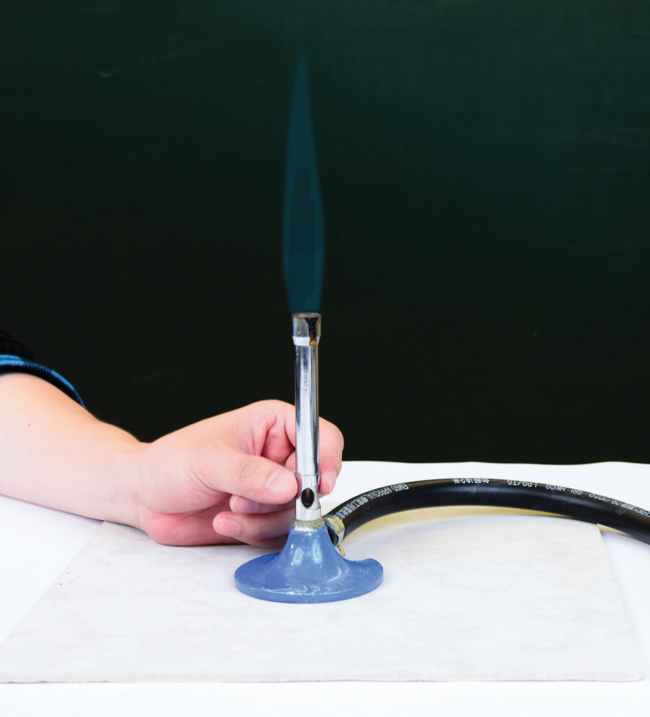

**6.** Slowly turn the collar to make the air hole half open.

**• Questions**

**(a)** What will happen if we open the air hole before lighting a Bunsen burner?

**(b)** If the phenomenon in **(a)** really happens, what should we do at once?

**2.** Before doing Experiment 7.2, let’s recall the correct way of taking a reading from an alcohol thermometer learnt in Book 1A Ch. 1, as follows:

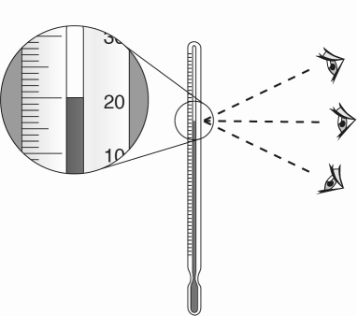

**✓**

**🗶**

**🗶**

our eyes must be at the same level as the liquid level in the thermometer

°C

**• Question**

What is the reading of the thermometer shown above?

ANSWERS

**1.** **(a)** Striking back

**(b)** Turn off the gas tap at once and tell the teacher.

**2.** 20 °C